Software Requirements Specification (SRS)
Project Name: Rangefinder
Version: 1.0
Date: 2026-03-13
Author(s): Jan Frančák, Jaroslav Vaněček, Jakub Šoma, Tomáš Elexa, Lola Rodríguez

The most important notes:
- Use only those parts of this document that make sense for your project; use ‘Not applicable’ in other case
- if you do not know which part of this document is more relevant to your description, just use one and put links to the others
- if no part of this document seems to be relevant to your project-specific description, just use the section Other Requirements
- use a simple and to-the-point language, do not be vague
- do not use conditionals; use priorities if necessary

Introduction

1.1 Purpose

This document specifies the requirements for the Rangefinder, a Raspberry PI based range-finding tool with a mobile phone app user interface. Its users are able to see the real time measurements of distance together with a chart to easily see any outliers.

1.2 Document conventions

- Requirement IDs: FREQ-x for functional requirements; NFREQ-x for nonfunctional requirements; SCN-x for scenarios.
- Time is stated in seconds; availability in %; data sizes in MB/GB

1.3 Intended Audience and Reading Suggestions

- Product owner / client: read Sections 1–3 for scope, users, and scenarios; skim 4 and 6 for priorities.
- Developers / architects: read Sections 2, 4–8; start with 7 for architecture constraints
- Testers / QA: read Sections 3, 4, 6 and Appendix A for traceability and acceptance criteria.
- Operations / security: read Sections 2.4–2.7 and 6.2–6.4
- ZKONTROLOVAT

1.4 Product Scope

The Rangefinder provides a real time measurement of distance from the sensors mounted on the Raspberry PI, that are transmitted by bluetooth to a mobile phone app. Once the user pairs his app to the gadget, he will be able to see measurements of each sensor, the chart showing the measurements in a time period and a debug window for the bluetooth connection. This version (1.0) focuses on the foundation of a more complex rangefinder, allowing easy further development.

1.5 References

Raspberry PI: https://www.raspberrypi.com

2. Overall Description

2.1 Product Perspective
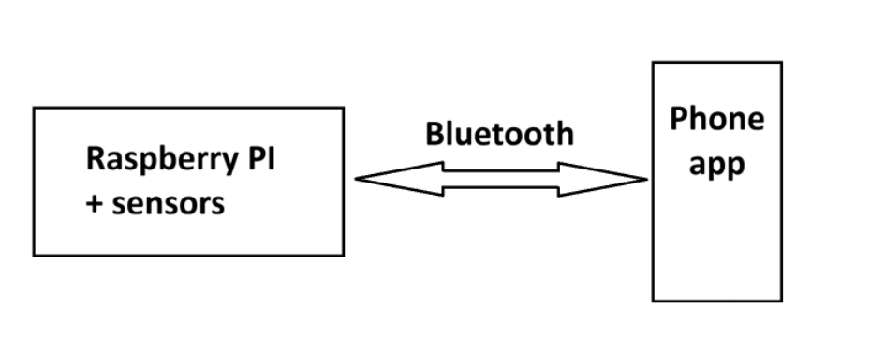
Figure 2.1 - Rangefinder context diagram

Rangefinder is a new product based on the Raspberry PI helping with commercial-use distance measurement. Together with the Raspberry PI chassis is an in-house built phone application that shows all measured data. The context diagram shows a simplified look at the workings of the system.

2.2 Product Features/Functions

Real-time measurements of each sensor
- Chart showing measurements over a set period of time
- Debug window for bluetooth connection
- True/False obstacle checker

2.3 User Classes and Characteristics

Not applicable

2.4 Operating Environment

Describe the environment in which the system will run - including hardware, operating system type and version, geographic location of users, servers, and databases. List all software components and systems that the system must work with.
DODELAT

2.5 Design and Implementation Constraints

Describe any factors that limit developers' capabilities and the reasons for these limitations (specific technologies, programming languages, types of web browsers, data exchange formats, etc.)
DODELAT

2.6 User Documentation

- PDF user manual
- PDF troubleshooting guide
- Release notes per version

2.7 Assumptions and Dependencies

- Stable Bluetooth connection
DODELAT???

3. System scenarios (Use cases)

3.1 Use-case diagrams

In this section, provide use-case diagrams of your system. It should be at least one. If there is not enough space inside on the page or inside the diagram, break it in two. This split is also beneficial for grouping the various scenarios. Keeping each scenario and its dependent scenarios in one diagram is also recommended.

3.2 Scenarios

3.2.1 SCN-1: User measures a distance

FREQ reference | FREQ-2, FREQ-3
NFREQ reference | NFREQ-3, NFREQ-4, NFREQ-5
Short Description: | User uses the application installed on his phone to measure a distance from the Rangefinder to a certain object
Activation action: | NA
Precondition: | User is correctly connected to the Rangefinder using bluetooth

Basic flow: User measures a distance
Step | User action |  | System response
1 | Clicks on the app icon |  | App gets opened on his phone
2 | Selects the “Advanced menu” |  | “Advanced” menu window gets opened
3 | Views the measured data |  | NA
4 | Closes the app |  | App gets shut down
Post-condition: |  | Rangefinder keeps sending new data as long as it is not turned off

3.2.1.1 Alternative flows
A1 - View of the sensors is obstructed
- Trigger: An obstacle is located in front of the sensors
- System response: The obstacle sensor is returning True value, which is shown in the menu
- Result: The user inspects the Rangefinder to remove the obstacle

3.2.2 SCN-2: <Scenario name (a sentence)>
<Your second scenario…>

4. Functional Requirements

4.1 FREQ-1 - Connecting to the Raspberry
Description: The phone app shall allow the user to connect to the Raspberry using bluetooth
Priority: High
Acceptance criteria: Given the bluetooth is working correctly on both devices, the user is able to connect to the Raspberry and starts to receive data, that is then displayed.

4.2 FREQ-2 - Displaying data
Description: The phone app shall allow the user to see data from each of the sensors, including the True/False obstacle detector.
Priority: High
Acceptance criteria: Given the user is connected to the Raspberry, they can clearly see data from each sensor in the “Advanced” menu of the app and min/max value in the “Simple” menu of the app.

4.3 FREQ-3 - Displaying the chart
Description: The phone app shall allow the user to see data from all the sensors on the chart.
Priority: Medium
Acceptance criteria: Given the user is connected to the Raspberry, they can see the chart in the “Advanced” menu of the app and they can distinguish each sensor by their assigned color.

4.4 FREQ-4 - Displaying the Debug window
Description: The phone app shall allow the user to see the Debug window.
Priority: Medium
Acceptance criteria: Given the user is connected to the Raspberry, they can see the debug window on the bottom of the “Advanced” menu, where the entire bluetooth connection between the devices is continuously displayed.

5. External Interface Requirements

5.1 User Interfaces (UI design / User Interaction Flow)
Describe the logical characteristics of each interface between the software product and the users. This may include sample screen images, any GUI standards or product family style guides to be followed, screen layout constraints, standard buttons and functions (e.g., help) appearing on every screen, keyboard shortcuts, error message display standards, etc. Define the software components for which a user interface is needed. The user interface design might also be documented in a separate user interface specification.
- UI should include: Advanced menu, Simple menu

5.2 Hardware Interfaces
Describe the logical and physical characteristics of each interface between the software product and the hardware components of the system. This may include the supported device types, the nature of the data and control interactions between the software and the hardware, and the communication protocols to be used.
5.3 Software Interfaces (API Interfaces)
Describe the connections between this product and other specific software components (name and version), including databases, operating systems, tools, libraries, and integrated commercial components. Identify the data items or messages coming into the system and going out and describe the purpose of each. Describe the services needed and the nature of communications. Refer to documents that describe detailed API protocols. Identify data that will be shared across software components. If the data-sharing mechanism must be implemented in a specific way (for example, using a global data area in a multitasking operating system), specify this as an implementation constraint.

5.4 Communications Interfaces
Describe the requirements associated with any communications functions required by this product, including e-mail, web browser, network server communications protocols, electronic forms, etc. Define any pertinent message formatting. Identify any communication standards that will be used, such as FTP or HTTP. Specify any communication security or encryption issues, data transfer rates, and synchronization mechanisms.

6 Other Nonfunctional Requirements

6.1 Performance Requirements
Not applicable. / ZEPTAT SE RYCHLIKA

6.2 Safety Requirements
Not applicable

6.3 Security Requirements
Not applicable
6.4 Software Quality Attributes
Specify any additional quality characteristics for the product that will be important to the customers or the developers. Some to consider are adaptability, availability, correctness, flexibility, interoperability, maintainability, portability, reliability, reusability, robustness, testability, and usability. Write these to be specific, quantitative, and verifiable when possible. At the least, clarify the relative preferences for various attributes, such as ease of use over ease of learning.
- NFREQ-1 (Correctness): The system shall measure with a DOPLNIT accuracy.
- NFREQ-2 (Maintainability): Codebase shall include automated tests covering at least 60% of backend logic and 40% of frontend components.
- NFREQ-3 (Portability): The application shall work with any modern android phone.
- NFREQ-4 (Usability): The application shall display all measured distances within at maximum half a second.

7 System Design & Architecture

7.1 High-Level Architecture
Provide a diagram and description of the system’s architecture, showing key components and their interactions.
UDELAT DIAGRAM

7.2 Technology Stack
List technologies, frameworks, and tools used for building the system, such as:
- Backend: Node.js, Java
- Frontend: React, Angular
- Database: PostgreSQL
DODELAT

7.3 Data Flow
Data is collected from a single sensor -> Data is transferred by bluetooth to the mobile device application -> Data is parsed and displayed in the application.

8 Other Requirements
None.

